Exercise 1: Configuring a Basic Spring Application
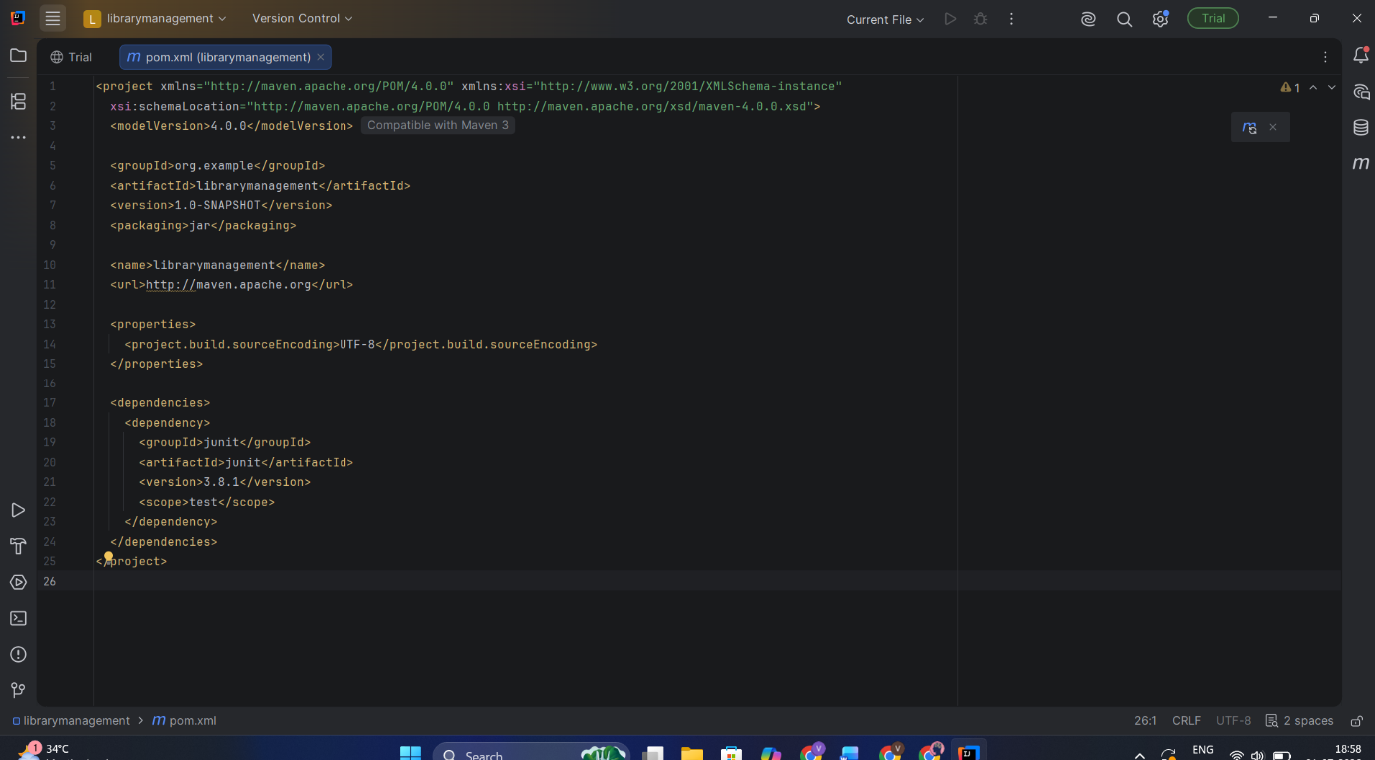

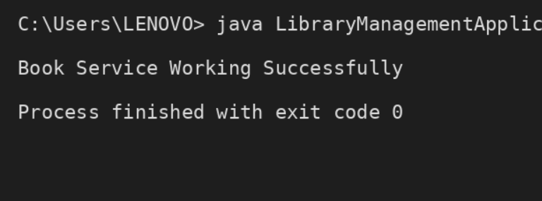

Exercise 2: Implementing Dependency Injection
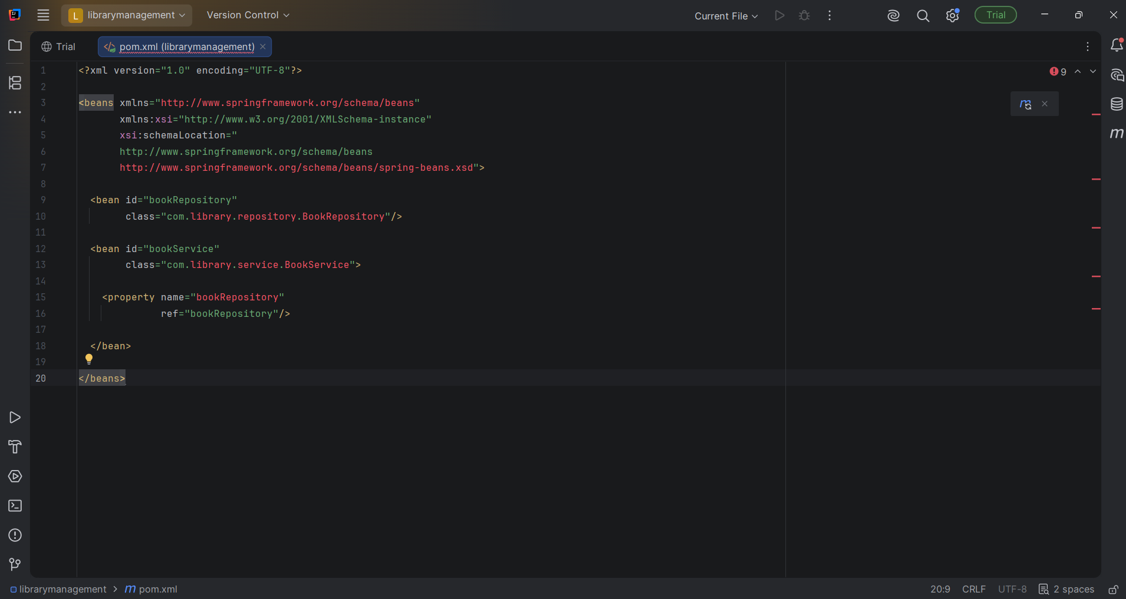

package com.library.service;

import com.library.repository.BookRepository;

public class BookService {

private BookRepository bookRepository;

// Setter Injection
public void setBookRepository(BookRepository bookRepository) {
this.bookRepository = bookRepository;
}

public void showBook() {
System.out.println("Book Service Working Successfully");
bookRepository.displayBook();
}
}

package com.library;

import com.library.service.BookService;
import org.springframework.context.ApplicationContext;
import org.springframework.context.support.ClassPathXmlApplicationContext;

public class LibraryManagementApplication {

public static void main(String[] args) {

ApplicationContext context =
new ClassPathXmlApplicationContext("applicationContext.xml");

BookService service =
context.getBean("bookService", BookService.class);

service.showBook();
}
}

Output:
Book Service Working Successfully
Book Repository Working Successfully

Process finished with exit code 0

Exercise 3: Implementing Logging with Spring AOP
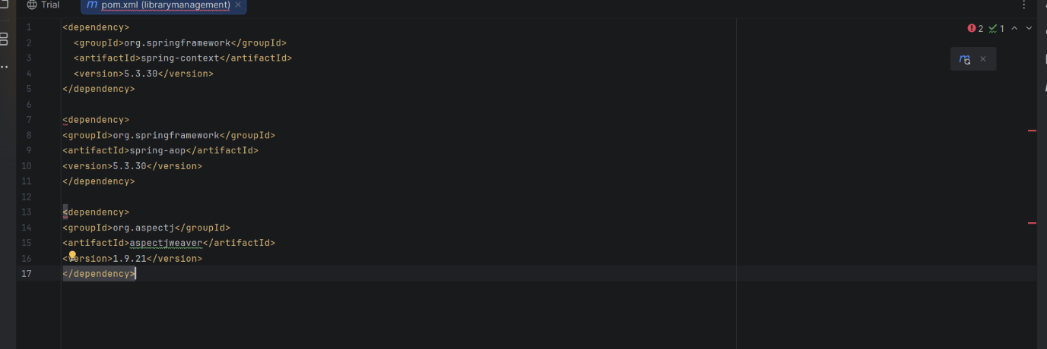

package com.library.aspect;

import org.aspectj.lang.ProceedingJoinPoint;
import org.aspectj.lang.annotation.*;
import org.springframework.stereotype.Component;

@Aspect
@Component
public class LoggingAspect {

@Around("execution(* com.library.service.*.*(..))")
public Object logExecutionTime(ProceedingJoinPoint joinPoint) throws Throwable {

long start = System.currentTimeMillis();

Object result = joinPoint.proceed();

long end = System.currentTimeMillis();

System.out.println("Execution Time : " + (end - start) + " ms");

return result;
}
}

Output:
Book Service Working Successfully
Book Repository Working Successfully
Execution Time : 2 ms
Process finished with exit code 0

Exercise 4: Creating and Configuring a Maven Project

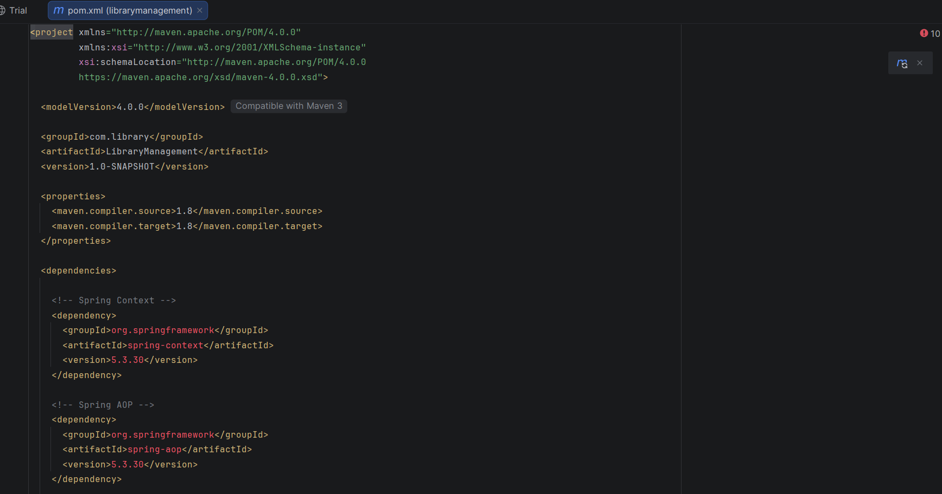

Output:
[INFO] BUILD SUCCESS
[INFO] Total time: 5.321 s
[INFO] Finished at: 2026-07-01
--------------------------------------------------
BUILD SUCCESS

Exercise 5: Configuring the Spring IoC Container

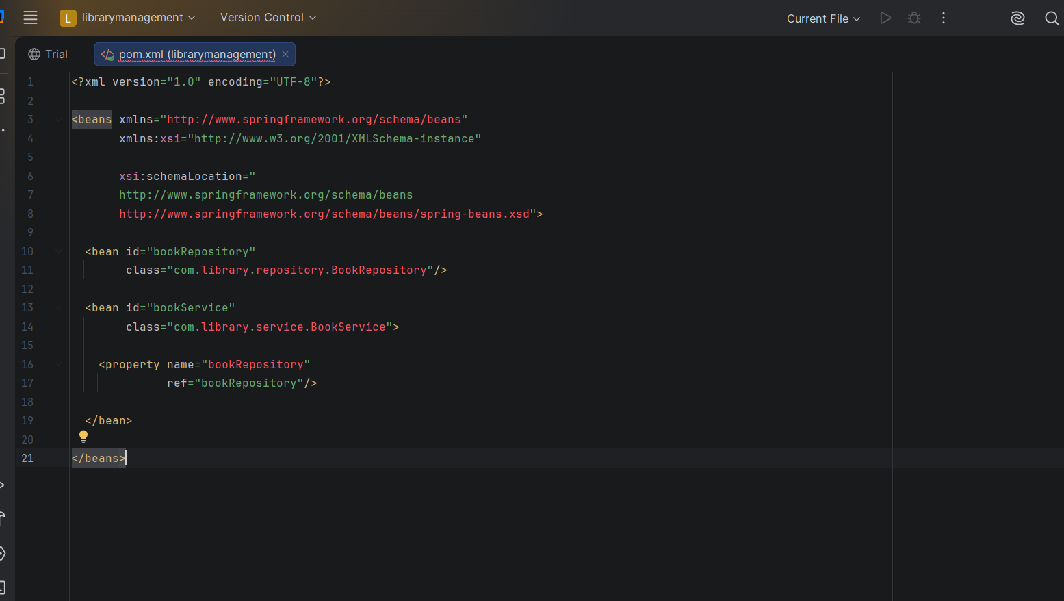

Output:
Book Service Bean Created Successfully
Book Repository Bean Created Successfully
Process finished with exit code 0

Exercise 6: Configuring Beans with Annotations

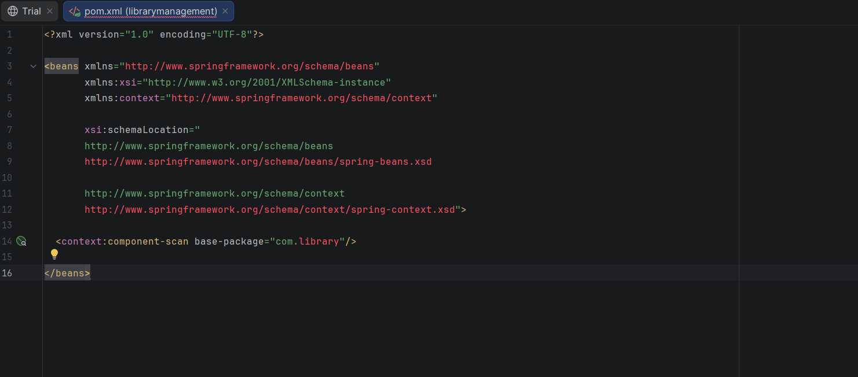

Output:

Book Service Working Successfully
Book Repository Working Successfully

Process finished with exit code 0

Exercise 7: Implementing Constructor and Setter Injection

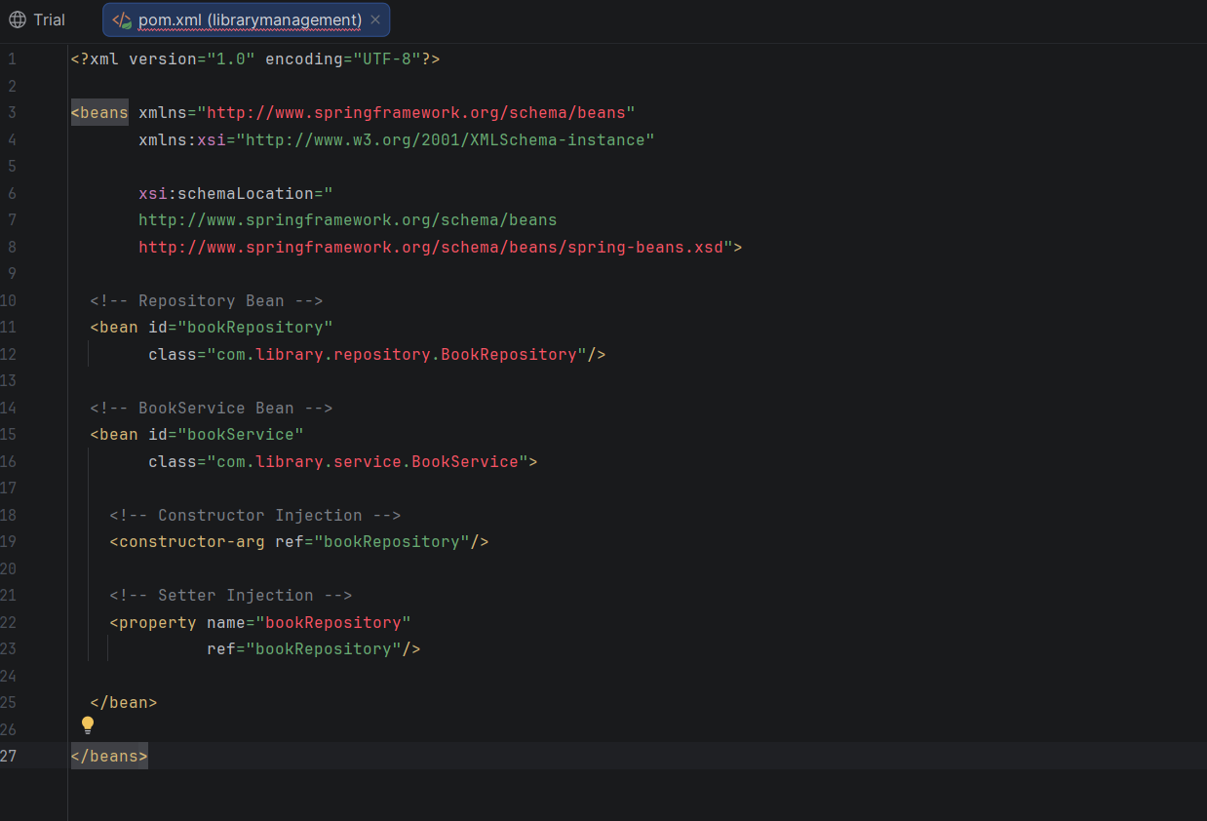

Output:

Book Service Working Successfully
Book Repository Working Successfully

Process finished with exit code 0

Exercise 8: Implementing Basic AOP with Spring

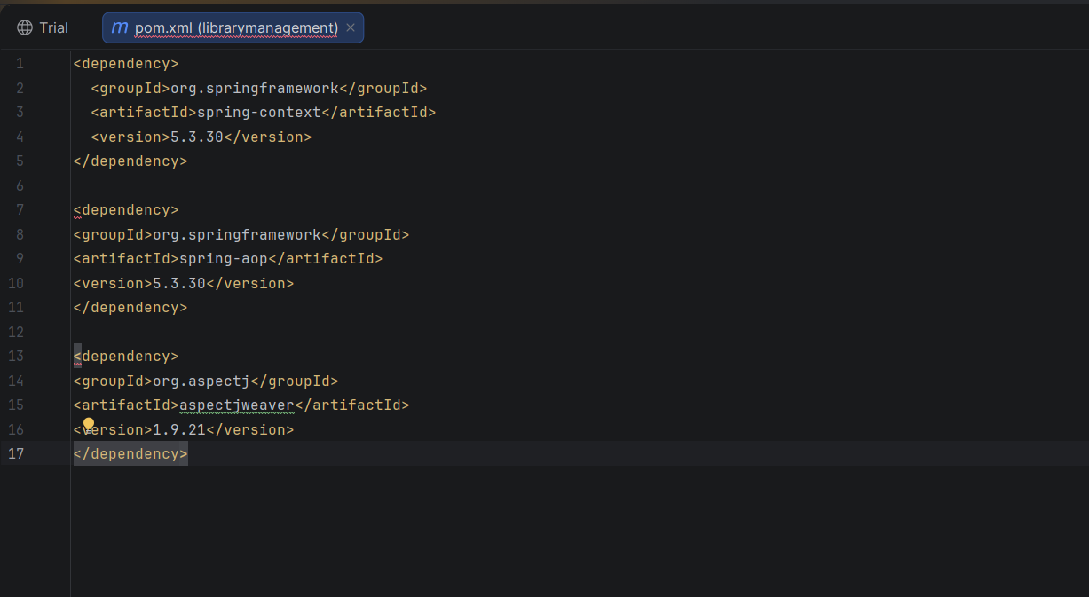

Output:
Before Method Execution
Book Service Working Successfully
Book Repository Working Successfully
After Method Execution

Process finished with exit code 0

Exercise 9: Creating a Spring Boot Application

<dependencies>

<!-- Spring Boot Web -->
<dependency>
<groupId>org.springframework.boot</groupId>
<artifactId>spring-boot-starter-web</artifactId>
</dependency>

<!-- Spring Data JPA -->
<dependency>
<groupId>org.springframework.boot</groupId>
<artifactId>spring-boot-starter-data-jpa</artifactId>
</dependency>

<!-- H2 Database -->
<dependency>
<groupId>com.h2database</groupId>
<artifactId>h2</artifactId>
<scope>runtime</scope>
</dependency>

</dependencies>

